*. Задача "Установить ClamAV на сервера XXI" (https://jira.tcsbank.ru/browse/IN-1118)[Ряковская Юлия][Задачу назначил Александров Алексей]. Созданный change request "Обновление clamav на серверах db (tst, stb, pre)" (https://jira.tcsbank.ru/browse/INCR-1842).
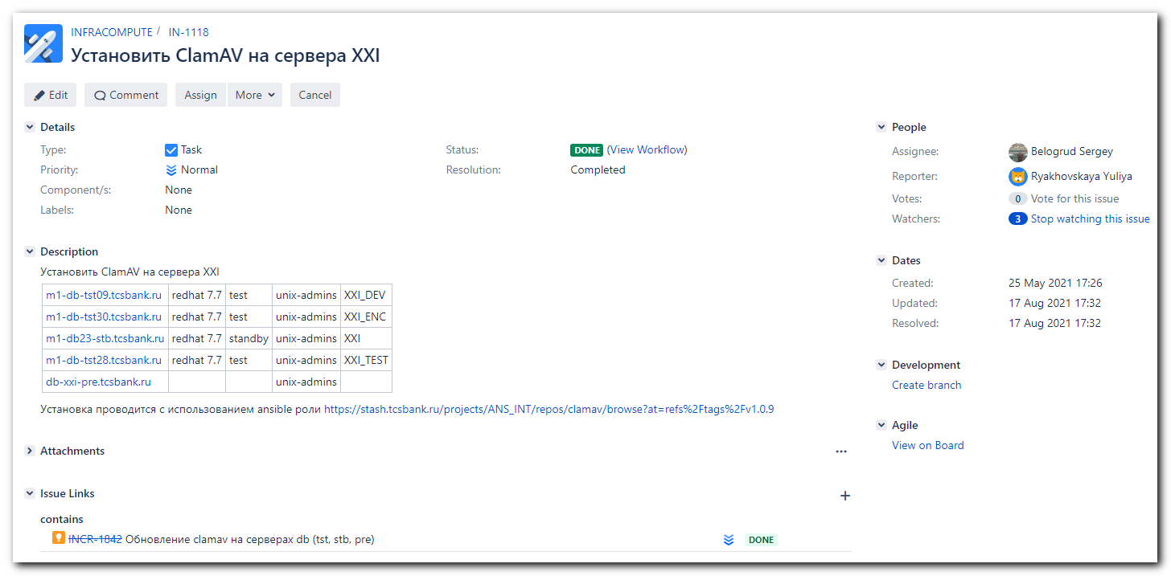
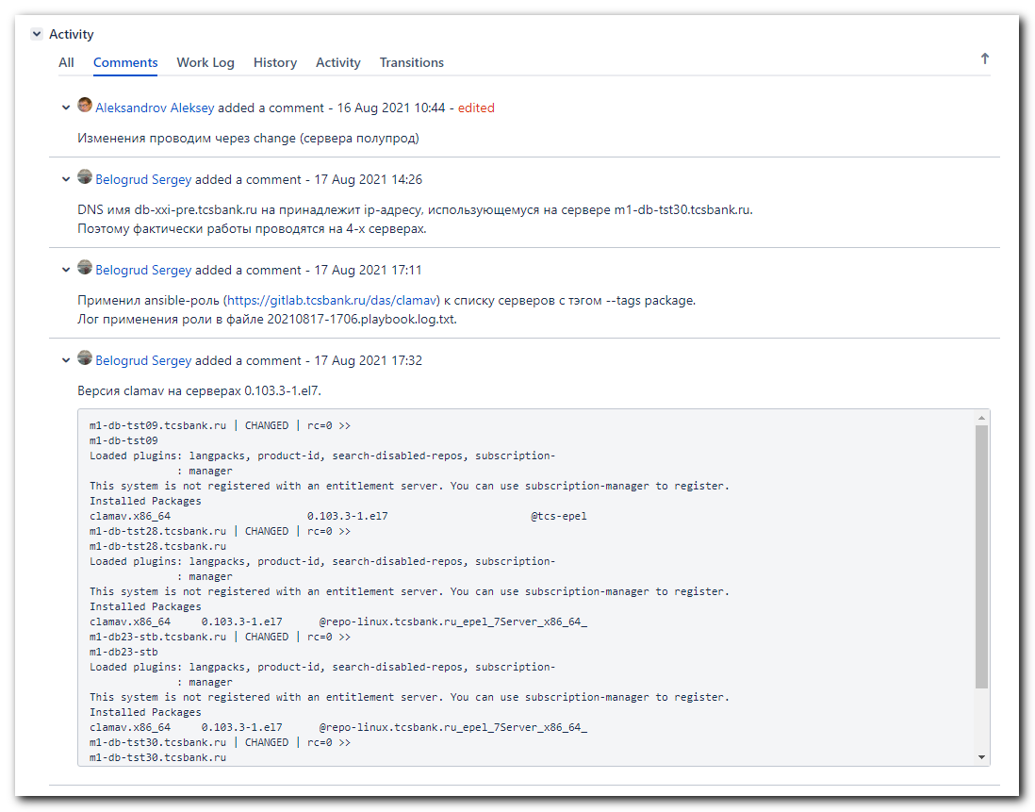

# Это Change request.
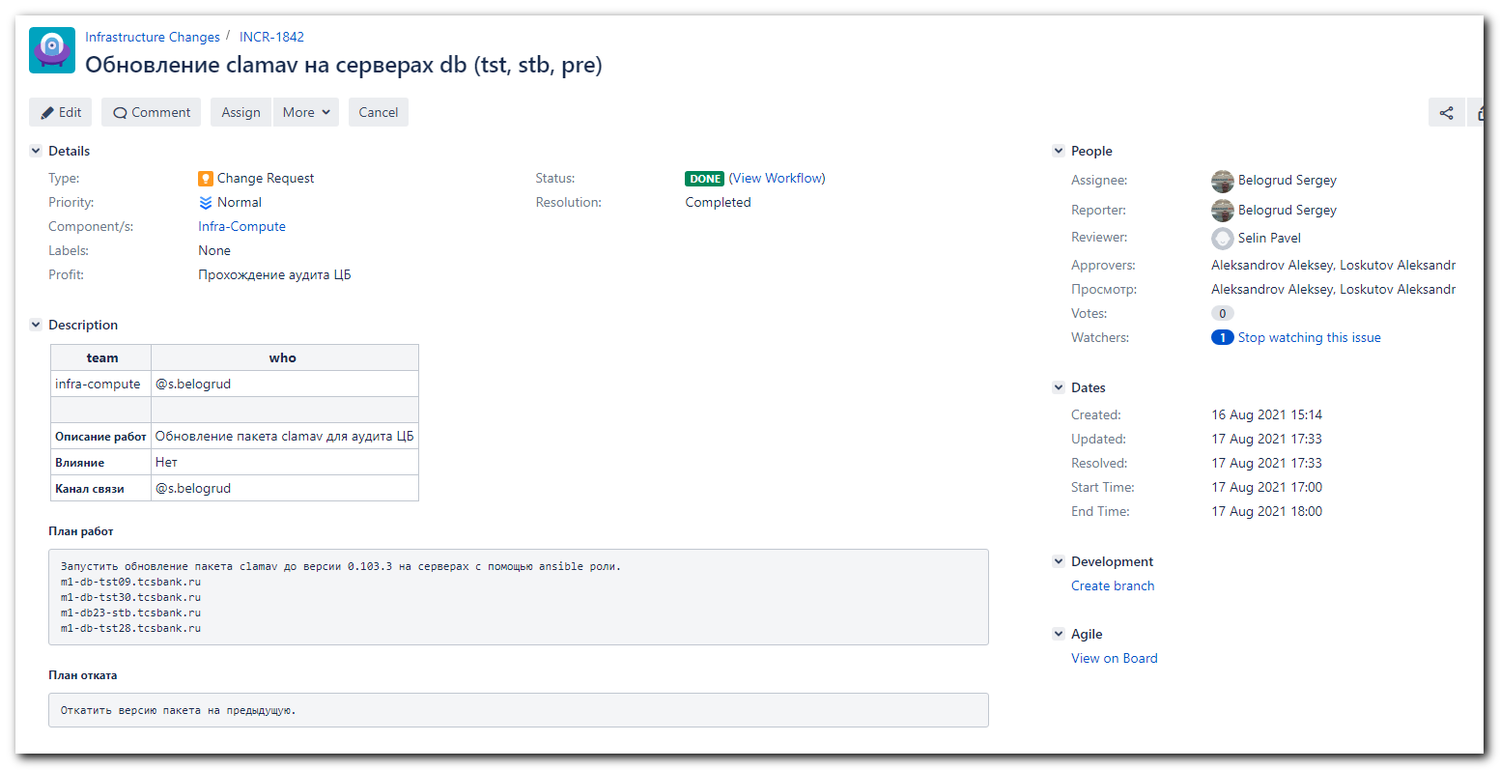
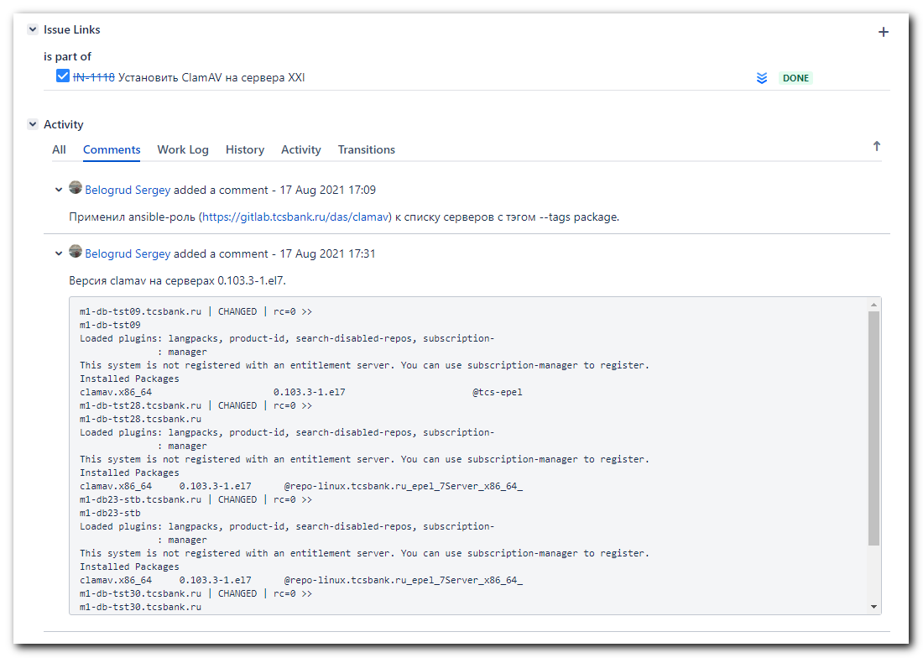
# Мой Change request делался по образу, который уже делал Сорокин Дмитрий (он предложил его в слаке).
https://jira.tcsbank.ru/browse/INCR-1833

https://tinkoff.slack.com/archives/D015M99KR5L/p1629103332000500
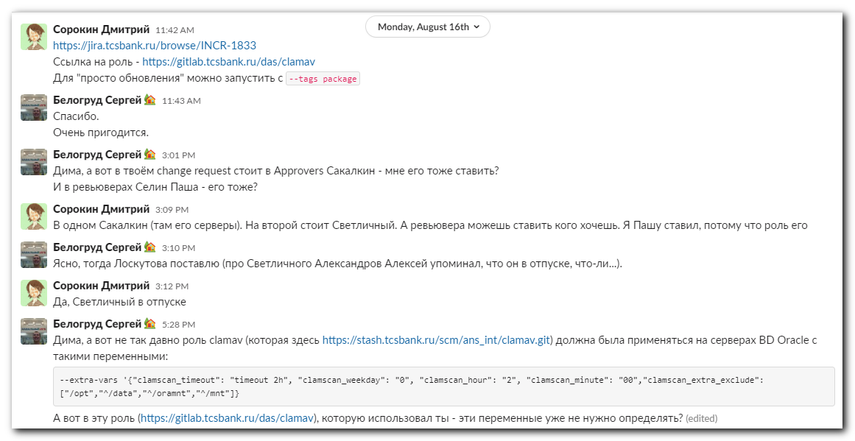
https://tinkoff.slack.com/archives/D015M99KR5L/p1629124306009700
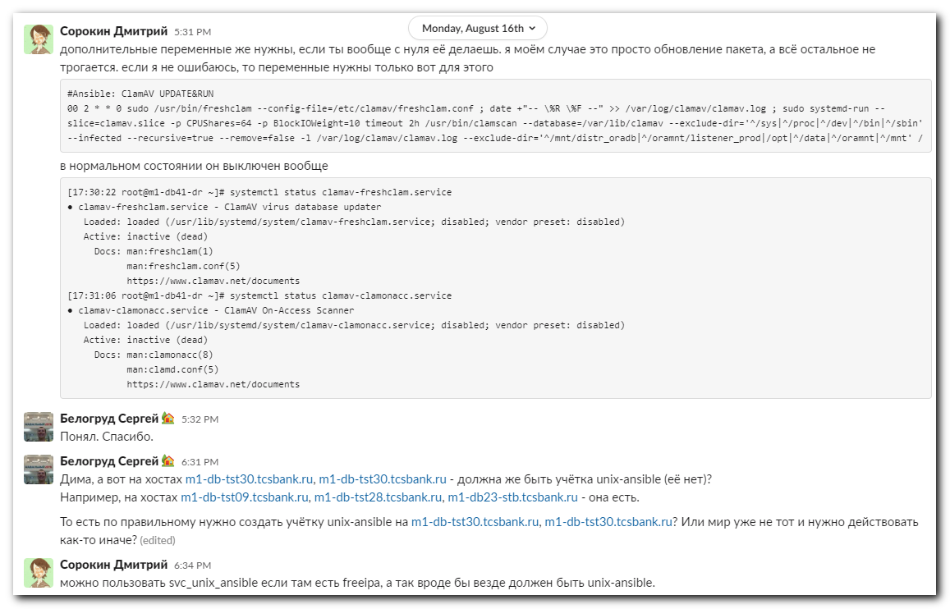
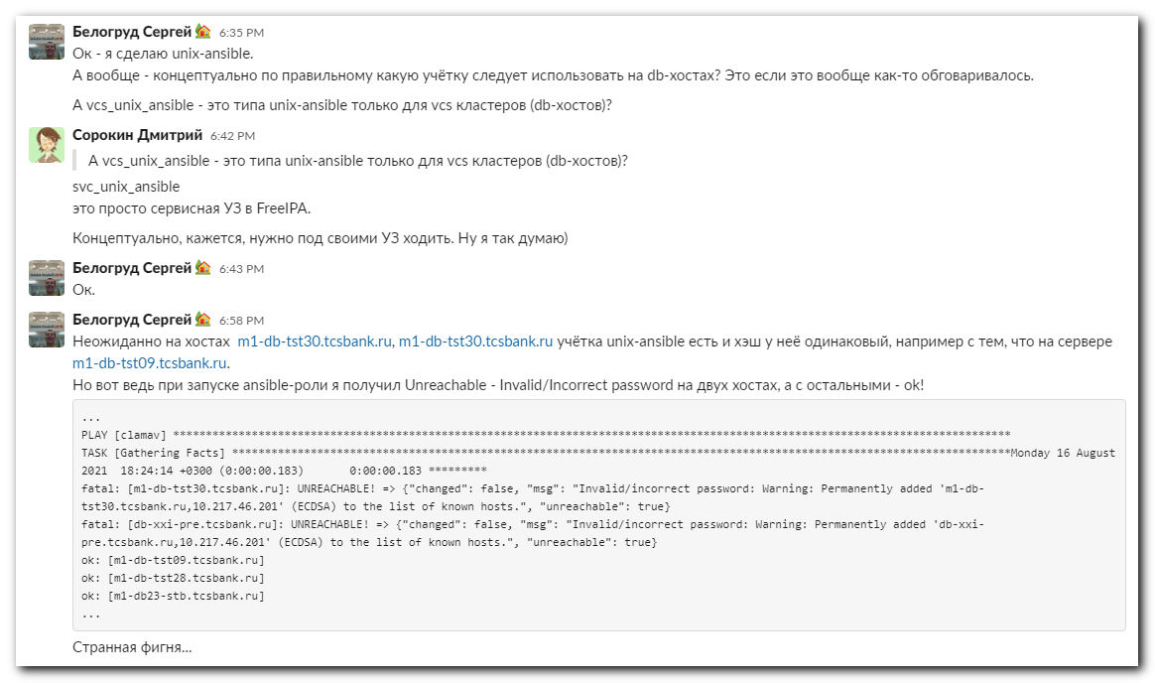

https://tinkoff.slack.com/archives/D3T62J36G/p1629199744000100
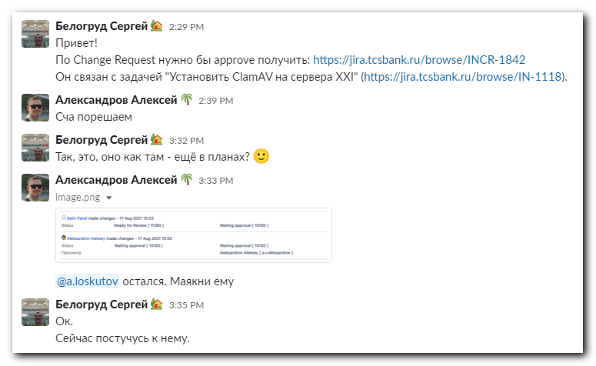

https://tinkoff.slack.com/archives/DBLMN4TEG/p1629203769000700
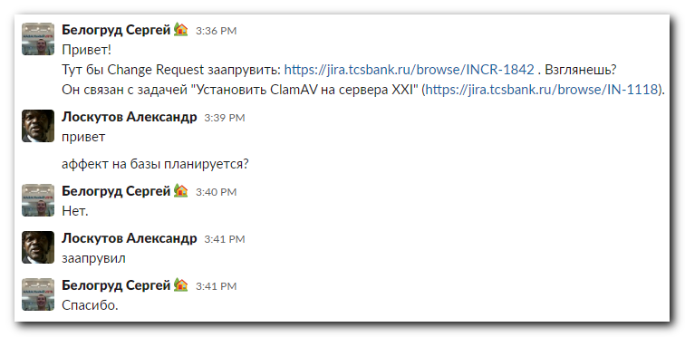

# I cloned repository 20210816 gitlab repository clamav.

#
# Here are commands I used to do this task.
#

# On two hosts I couldn't connect correctly with accoung unix-ansible. I tested why so, but didn't find answer.
[support@nb2339]# export ANSIBLE_CONFIG=ansible.cfg ; logfile="$(date +%Y%m%d-%H%M).playbook.log.txt" ; ansible-playbook 20210816-1812.clamav.yml -i list_of_hosts --become --extra-vars "ansible_user=unix-ansible ansible_password=$(pass common/linux-unix-ansible) ansible_sudo_pass=$(pass common/linux-unix-ansible) ansible_ssh_common_args='-oStrictHostKeyChecking=no -oPubkeyAuthentication=no -oUserKnownHostsFile=/dev/null'" --tags package --check | tee -a ./output/${logfile}

# I used my freeipa account to apply the ansible role.
[support@nb2339]# export ANSIBLE_CONFIG=ansible.cfg ; logfile="$(date +%Y%m%d-%H%M).playbook.log.txt" ; ansible-playbook 20210816-1812.clamav.yml -i list_of_hosts --become --extra-vars "ansible_user=s_s.belogrud ansible_password=$(pass common/linux-freeipa) ansible_sudo_pass=$(pass common/linux-freeipa) ansible_ssh_common_args='-oStrictHostKeyChecking=no -oPubkeyAuthentication=no -oUserKnownHostsFile=/dev/null'" --tags package --check | tee -a ./output/${logfile}

#
# I used this command to get version of camav to be sure that it was updated.
#
[support@nb2339]# export ANSIBLE_CONFIG=ansible.cfg ; logfile="$(date +%Y%m%d-%H%M).playbook.log.txt" ; ansible clamav -i list_of_hosts -m shell -a "hostname ; yum list installed clamav" --become --extra-vars "ansible_user=s_s.belogrud ansible_password=$(pass common/linux-freeipa) ansible_sudo_pass=$(pass common/linux-freeipa) ansible_ssh_common_args='-oStrictHostKeyChecking=no -oPubkeyAuthentication=no -oUserKnownHostsFile=/dev/null'" | tee -a ./output/${logfile}
m1-db-tst09.tcsbank.ru | CHANGED | rc=0 >>
m1-db-tst09
Loaded plugins: langpacks, product-id, search-disabled-repos, subscription-
: manager
This system is not registered with an entitlement server. You can use subscription-manager to register.
Installed Packages
clamav.x86_64 0.103.3-1.el7 @tcs-epel
m1-db-tst28.tcsbank.ru | CHANGED | rc=0 >>
m1-db-tst28.tcsbank.ru
Loaded plugins: langpacks, product-id, search-disabled-repos, subscription-
: manager
This system is not registered with an entitlement server. You can use subscription-manager to register.
Installed Packages
clamav.x86_64 0.103.3-1.el7 @repo-linux.tcsbank.ru_epel_7Server_x86_64_
m1-db23-stb.tcsbank.ru | CHANGED | rc=0 >>
m1-db23-stb
Loaded plugins: langpacks, product-id, search-disabled-repos, subscription-
: manager
This system is not registered with an entitlement server. You can use subscription-manager to register.
Installed Packages
clamav.x86_64 0.103.3-1.el7 @repo-linux.tcsbank.ru_epel_7Server_x86_64_
m1-db-tst30.tcsbank.ru | CHANGED | rc=0 >>
m1-db-tst30.tcsbank.ru
Loaded plugins: langpacks, product-id, search-disabled-repos, subscription-
: manager
This system is not registered with an entitlement server. You can use subscription-manager to register.
Installed Packages
clamav.x86_64 0.103.3-1.el7 @repo-linux.tcsbank.ru_epel_7Server_x86_64_
[support@nb2339]#

